Lecture-1

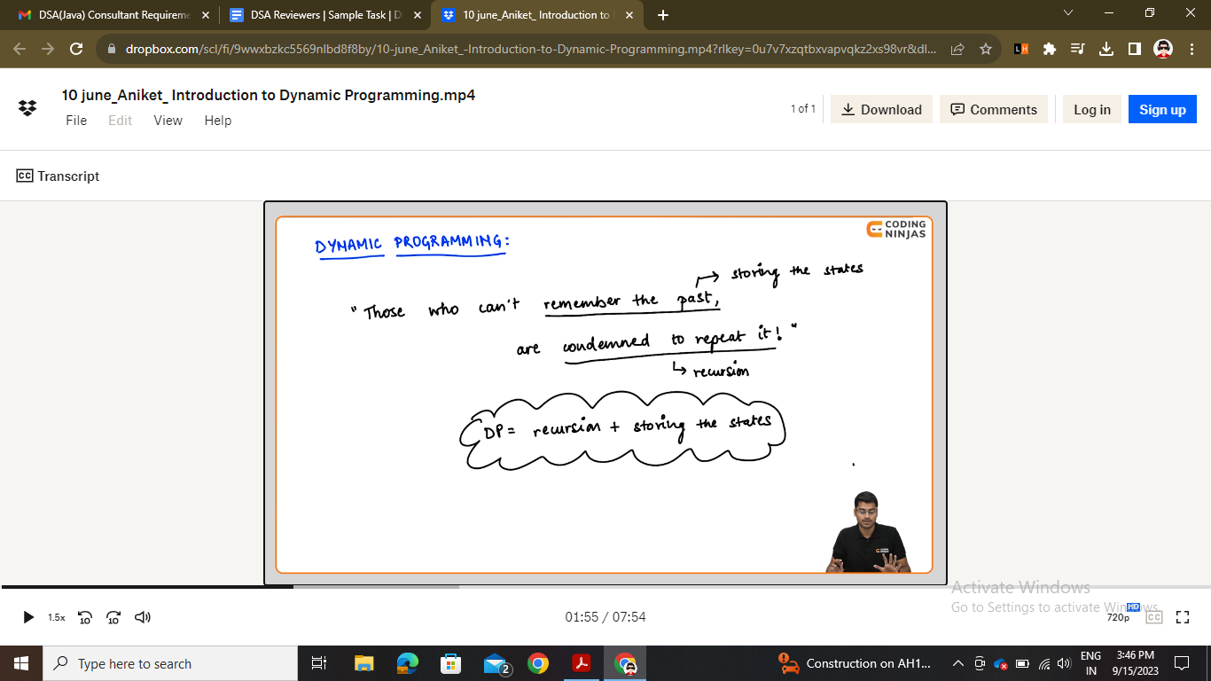

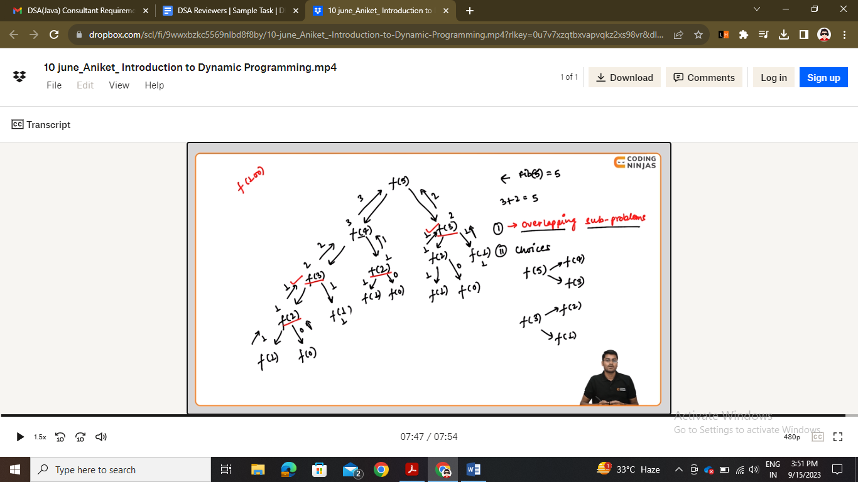

Two conditions of using dp

* Code of recursive-fib in background.
* F(n) -🡪 recursive tree bana chahiye -🡪 go to three levels -🡪 then explain by time complexity 2^n and by eliminating overlap states it should be o(n+1)

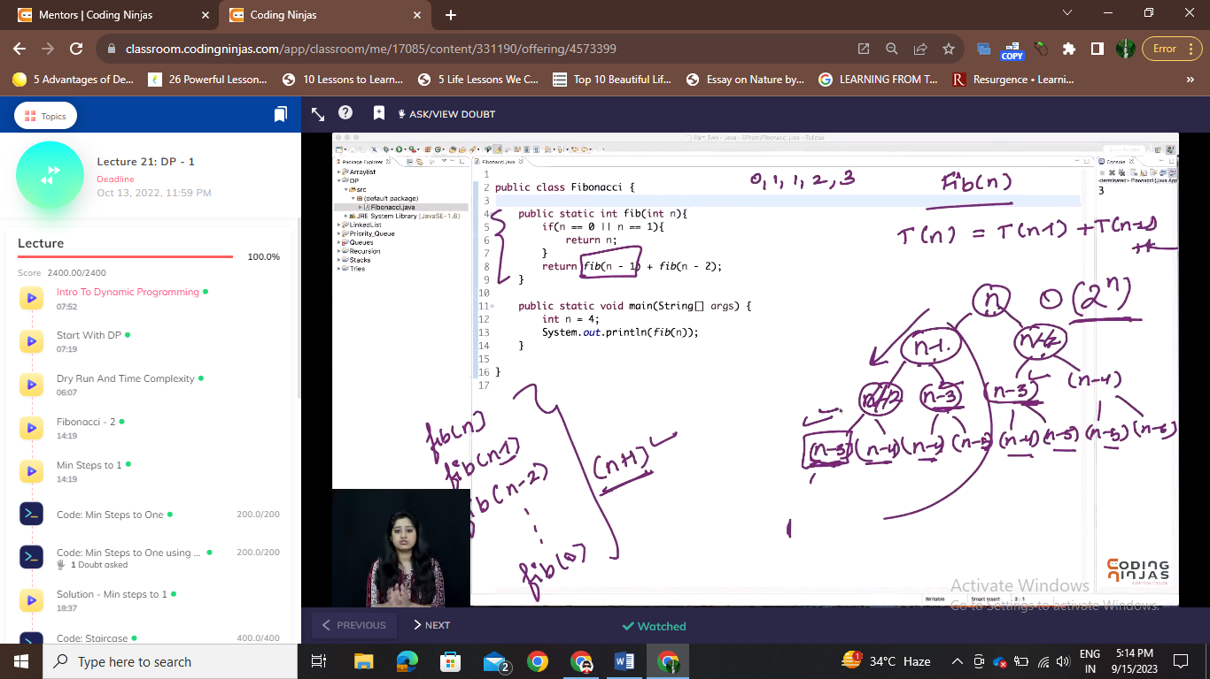

Lecture-2

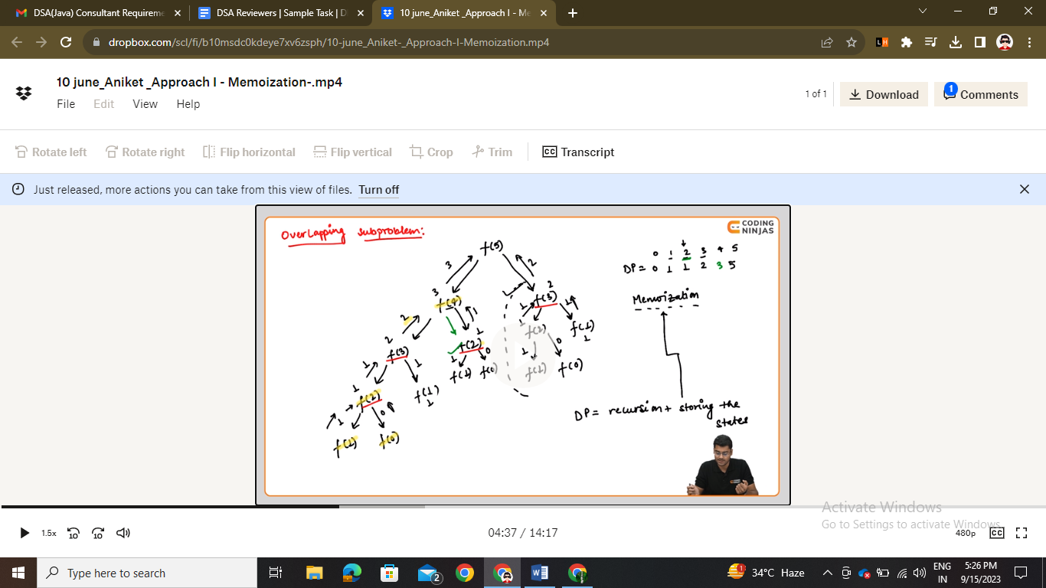

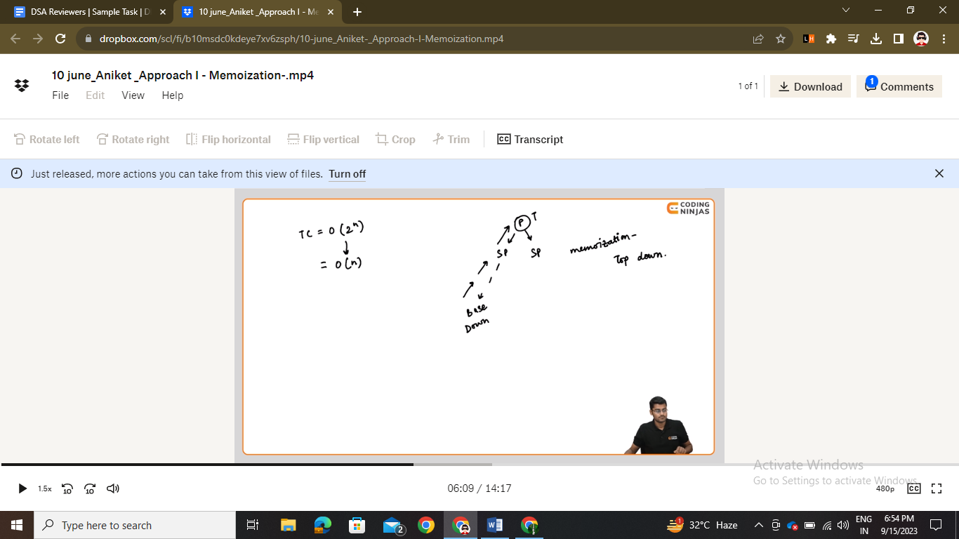

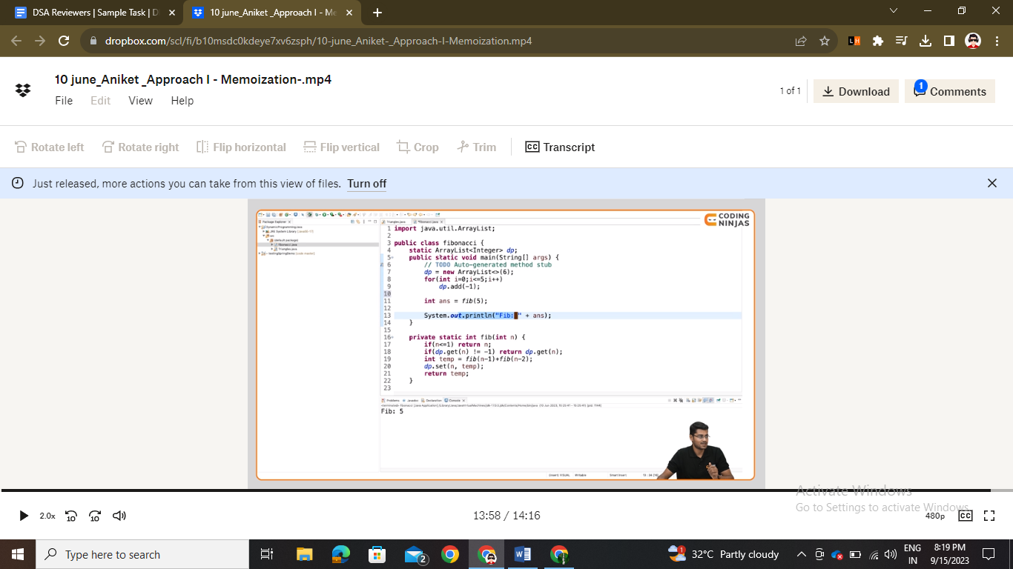

Changed from 2^n to linear o(n) and space complexity also o(n)

* 2 times eror shown

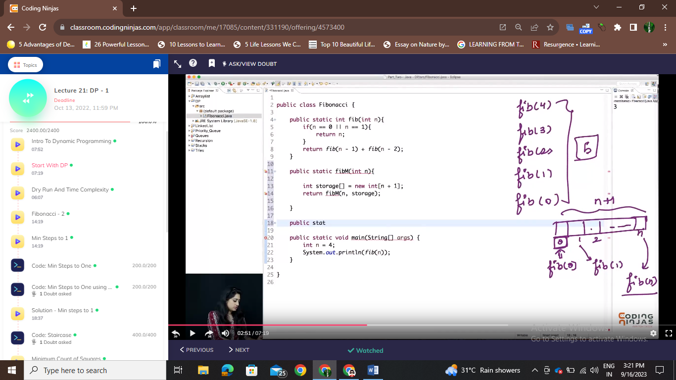

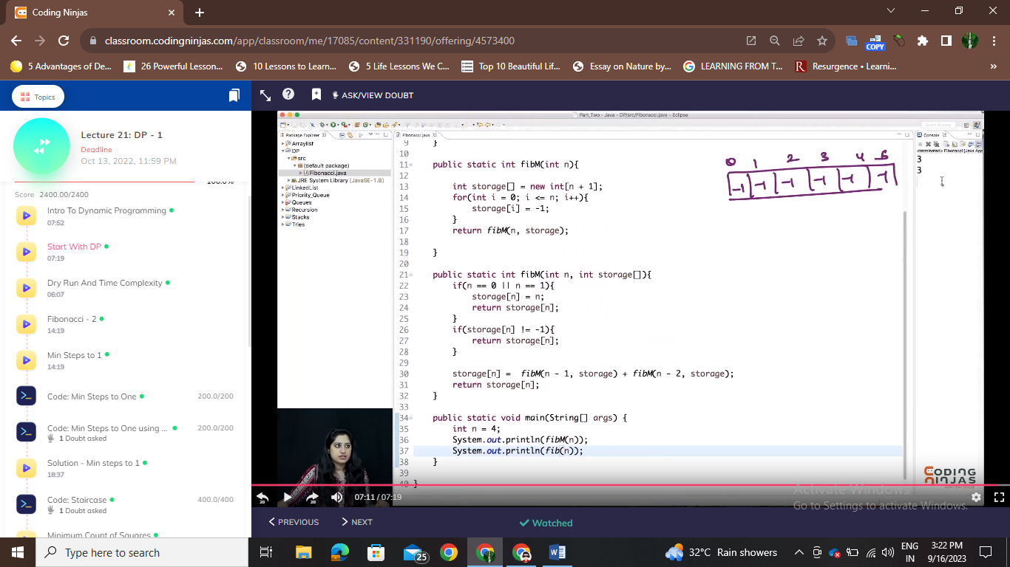

Lecture-3

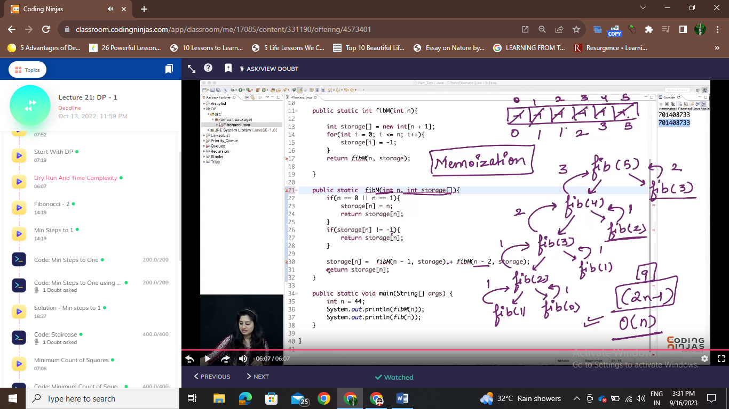

Lecture-4

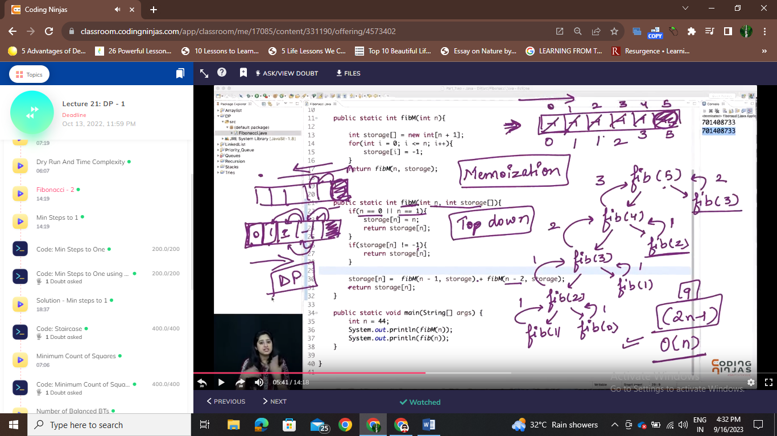

1st normal approach (remove multiple states)

2nd memorization (top-down approach)(remove recursion)

3rd dp (bottom-up approach)

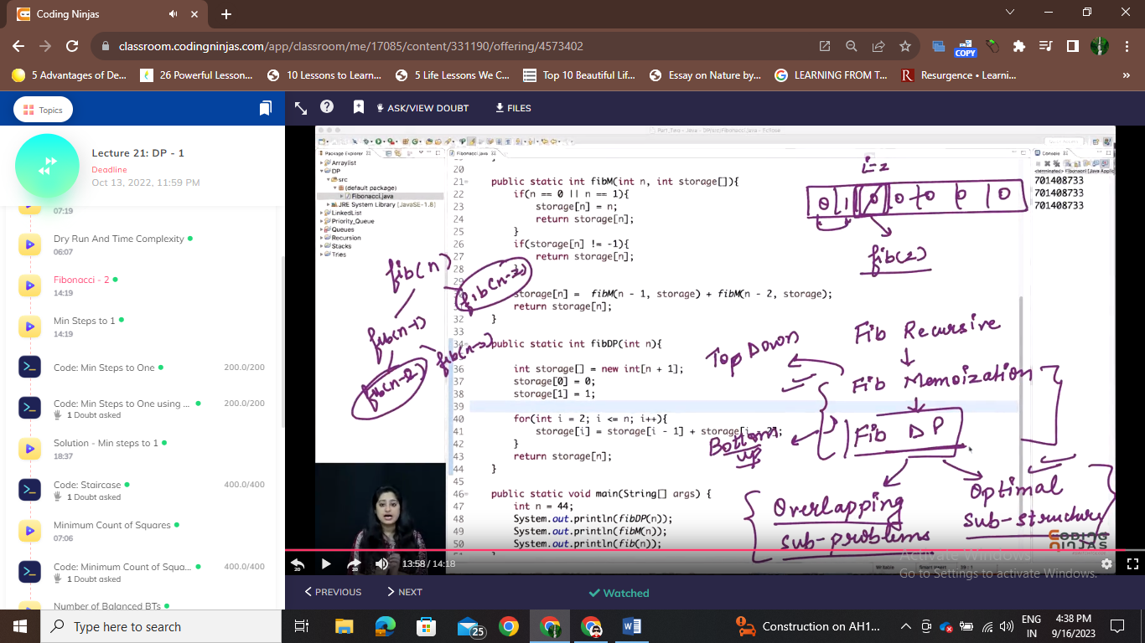

To use dp we should have two conditions

1. Overlapping subproblems
2. Optimal sub struvsture

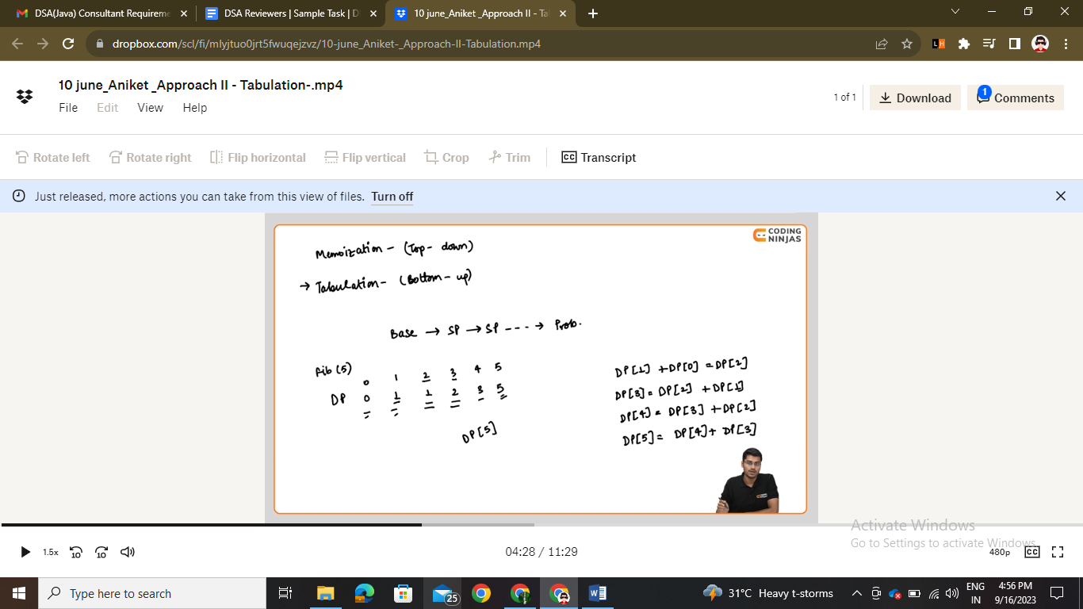

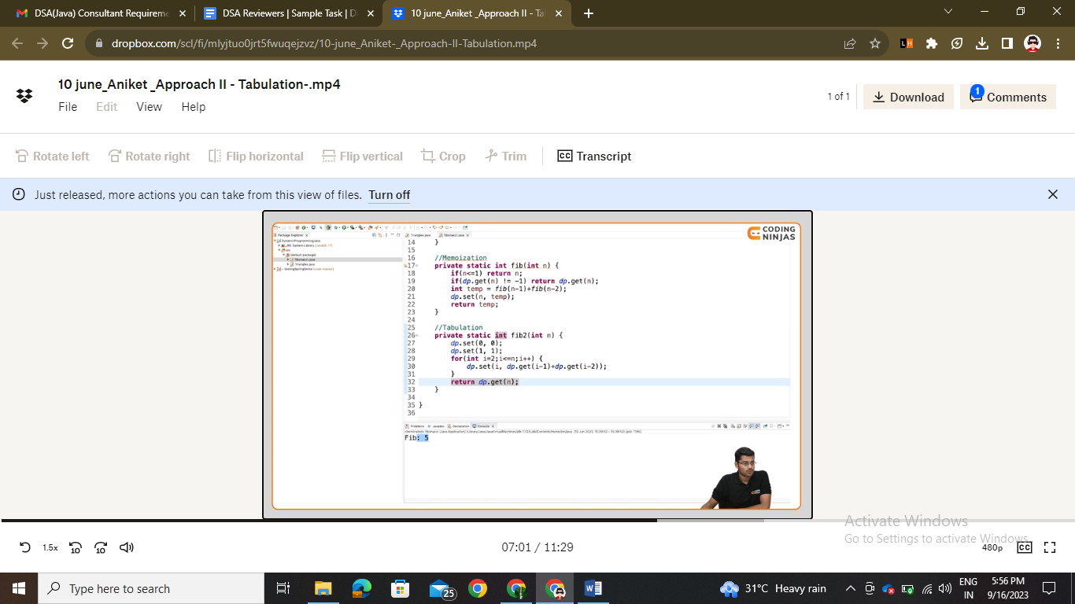

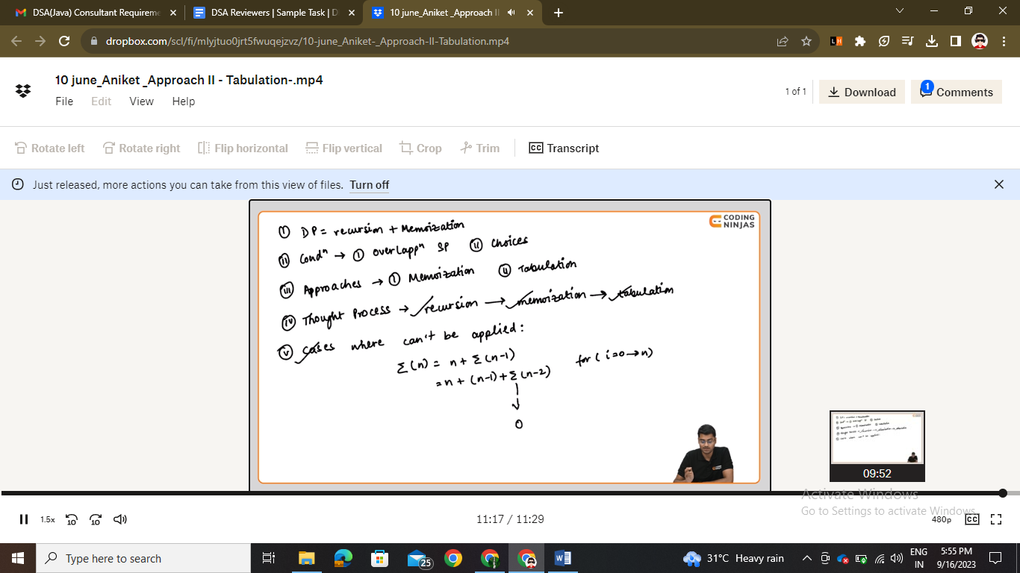

Lecture – 5

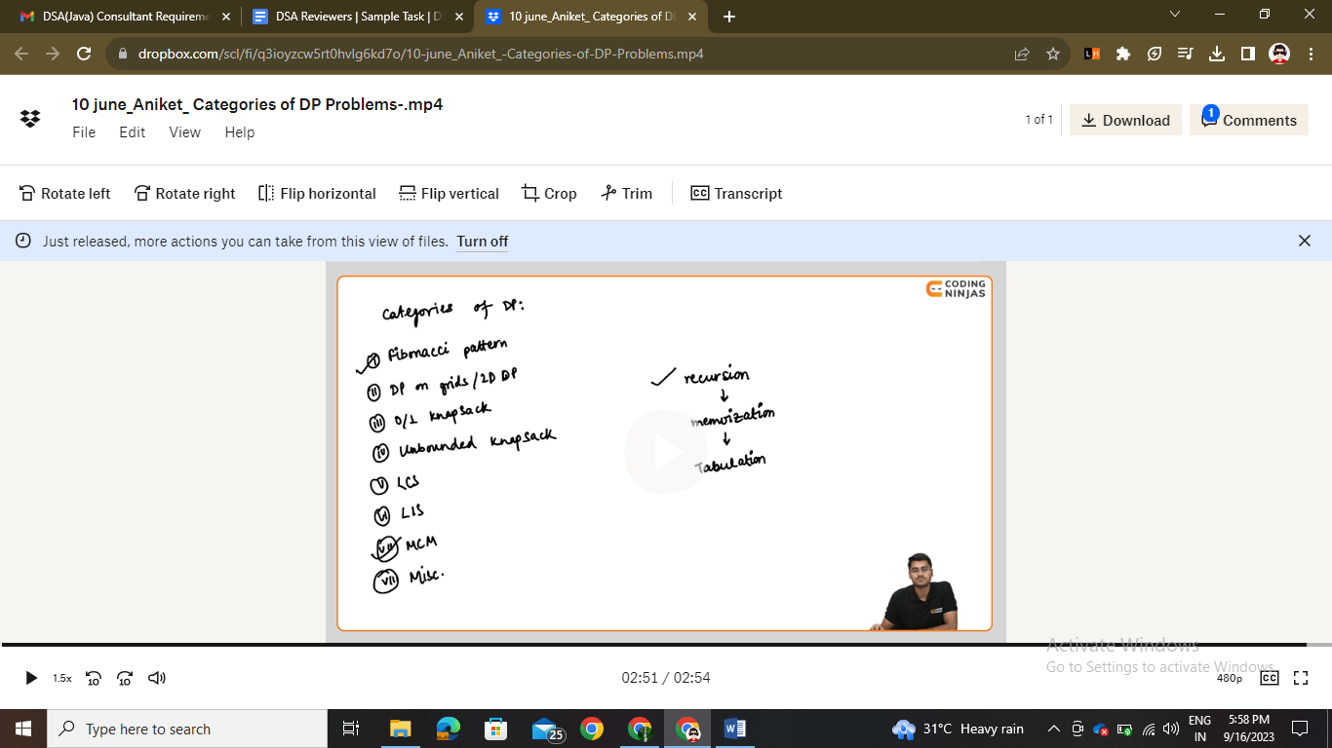

* Fibonacci pattern
* Dp on grids
* 0/1 knapsack
* Unbounded knapsack
* LCS
* LIS
* MCM (matrix chain multiplication)

